WIDOWED SUPPORT
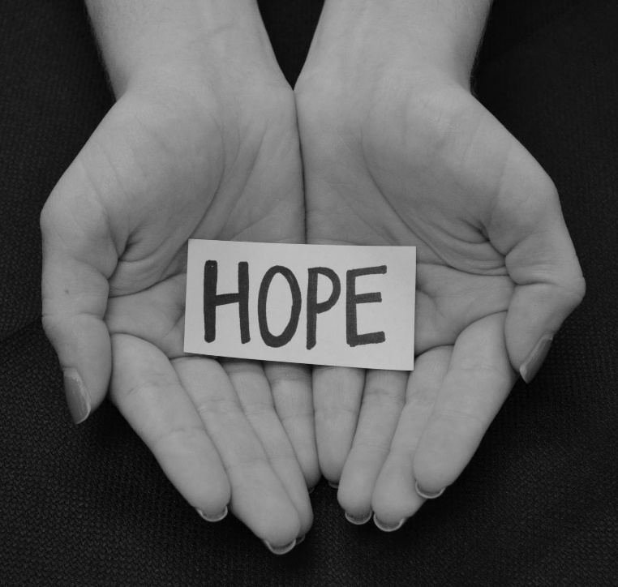 |  | There is Life after Loss  ​​If you have lost the person you planned to spend the rest of your life with, you probably feel like your whole world has caved in. I know I did.​  - ​​If you need a safe place to be around other widowed people, we are here for you.  - ​If you don’t know what you need or where to start, we are here for you.  - ​If nobody around you understands what you are going through, we do.  - ​If you need someone to stand by you while you try to pick up the shattered pieces of your life we are here for you.  ​​
My name is Chris Moore. I lost my wife, Barbara to lung cancer in July 2022. As I have struggled to pick up the broken pieces of my life I have learned that helping others is the best way to help myself. If you find yourself in this club that none of us signed up for called widowhood, you are welcome here. Please call or text 540-556-0650 with questions or to RSVP. We will be meeting twice a month. This time it will be at Golden Corral. I hope to see you there.

Golden Corral March 25, 2024
1441 Towne Square Blvd NW 5:30 PM
Roanoke, VA 24012

 |  | ROANOKE VA REGIONAL SOCIAL GROUP  https://widowedvillage.org/  540-556-0650

